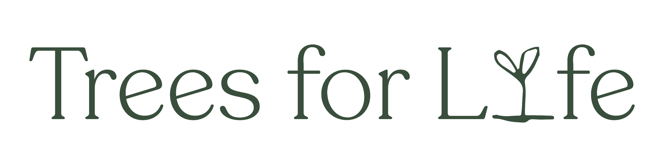

**Role Profile**

|  |  |
| --- | --- |
| **Job title** | Lynx to Scotland Engagement Officer (2 posts) |
| **Reporting to** | Lynx to Scotland Project Manager |
| **Has reporting** | None |
| **Starting Salary** | £25,983 per annum |
| **Duration** | 35 hours per week, Full-time fixed term until 7 Aug 2026 |
| **Location** | Findhorn, Moray/home-based |

**Trees for Life**

Trees for Life stands at the forefront of rewilding in the Scottish Highlands. Hopeful and bold, we are committed to creating nature-rich landscapes that include and support people. Working on a grand scale, we aim to close the gap between people and nature.

Focusing on Scotland’s spectacular Caledonian forest, we foster biodiversity and encourage natural processes essential to life. From the iconic red squirrel to the elusive lynx, we are working to bring more life back to our landscapes.

Rewilding is a shared journey. Together with communities, we are restoring Scotland’s natural and cultural heritage while supporting local livelihoods. Join us on this path of hope and positive action. Rewild the Scottish Highlands.

**Our values**

Our values are at the heart of our mission to rewild the Scottish Highlands, guiding us in everything from the daily rhythms of office life to the development of our landscape-scale initiatives. Sharing these values with our supporters, volunteers, and partners allows for a deeper understanding of our driving forces at Trees for Life.

**We are Bold**

We are an ambitious charity with a critical purpose. For us, being bold means thinking about landscape restoration on a grand scale, embracing innovative rewilding methods and challenging the status quo. This approach ensures that every step we take is a bold stride toward a revitalised, thriving natural landscape.

**We are Collaborative**

Our approach, deeply rooted in community and collaboration, involves working closely with local communities, conservation groups, landowners, and volunteers. Finding common ground and working together we will initiate positive solutions to the twin climate and biodiversity crises.

**We are Pragmatic**

We embrace pragmatic and sustainable solutions in everything we do. We are always mindful of our duty to our supporters, our volunteers, our staff and above all to Scotland’s wild forest. By adopting practical solutions, we safeguard our efforts and ensure a resilient future for our initiatives.

**Lynx to Scotland**

Lynx to Scotland is a partnership project between Trees for Life, Scotland: The Big Picture and the Lifescape Project, working to assess the feasibility of reintroducing the Eurasian lynx to the Scottish Highlands.

**Overall Purpose of the Job**

To design, carry out and evaluate elements of a consultation on lynx reintroduction with local communities that may be affected by a potential reintroduction.

**Key Liaisons**

Internally, the key liaisons for this role are: the Lynx to Scotland Project Manager, the Trees for Life CEO, the 2nd Engagement Officer and the communications team at Scotland:The Big Picture, who are a partner in the project. Externally, the post holder will liaise with local communities, landowners and land managers and relevant local organisations and groups.

**Key responsibilities**

* Represent Lynx to Scotland at Information Sessions designed to engage local communities in the consultation process and provide information about lynx and topics related to reintroduction.
* Arrange and hold one-to-one conversations with local landowners and practitioners who have concerns about lynx reintroduction.
* Identify relevant local organisations and groups to be targeted for consultation and arrange and attend meetings with these bodies.
* Collate and analyse responses to all consultation activities and produce a technical report of the process and its outcomes.
* Work with the Lynx to Scotland team to design sessions to report the findings of the consultation process back to the local communities and represent Lynx to Scotland at these meetings.
* Organise the advertising of the consultation process via flyers, posters and social media.
* Organise venues and logistics for consultation sessions.

**Person Specification**

The successful candidates will have proven experience in working with stakeholders on sensitive issues and ideally will have a background in nature restoration. They will need to be excellent communicators to engage with a diverse range of audiences and will have strong analytical and report-writing skills.

**Knowledge & Experience**

**Essential:**

* Experience of working with a range of stakeholders on sensitive issues, with demonstrable experience in understanding and working through concerns.
* Good general knowledge of ecology/nature restoration/conservation and the ability to quickly build a strong knowledge base within a specific area.
* Experience in collecting, collating and analysing both quantitative and qualitative data sets, including statistical analysis, and in writing technical reports.

**Desirable:**

* Experience of working in community consultation or social sciences (which can include MSc or PhD research experience), ideally within the field of conservation/ecological restoration.
* Knowledge of lynx as a species and the issues related to a potential reintroduction.
* An awareness of the ecological, cultural and political landscape in Scotland and issues related to species reintroductions and rural land management.
* Experience of working on wildlife reintroductions or ecosystem restoration projects.
* Education to degree level in a social science or ecology-related subject, or equivalent professional qualification within a relevant discipline.

**Personal Attributes**

* Personable and diplomatic.
* Resilient and able to manage sensitive conversations and situations.
* Strong self-motivation with the ability to work both autonomously without direct supervision and as part of a team.
* Willingness to represent Lynx to Scotland at official meetings, stakeholder forums and other relevant public events.

**Skills & Competencies**

* Ability to communicate confidently and sensitively and to build positive relationships with a diverse range of stakeholders.
* Ability to calmly manage sensitive conversations and keep conversations focussed.
* Highly organised with an ability to work under pressure to tight deadlines and to juggle multiple strands of work at once.

**Working conditions / Special demands**

* The role will involve travelling widely across the Scottish Highlands and Moray with overnight stays. Candidates must hold a full UK driving licence and be comfortable driving long distances and working alone.
* Consultation sessions will be held at a variety of times. Significant weekend and evening working will be required.